Polisens IF Diving and Marginalen Bank are pleased to invite clubs and federations our International Diving Competition in Stockholm, Sweden
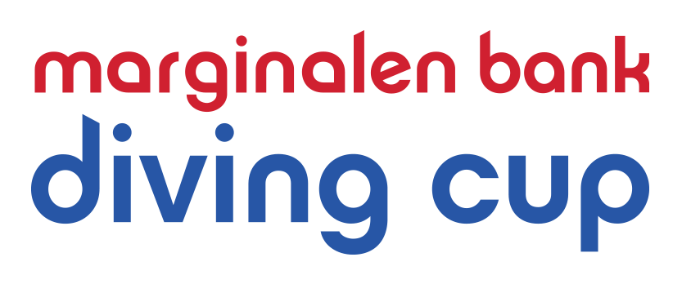

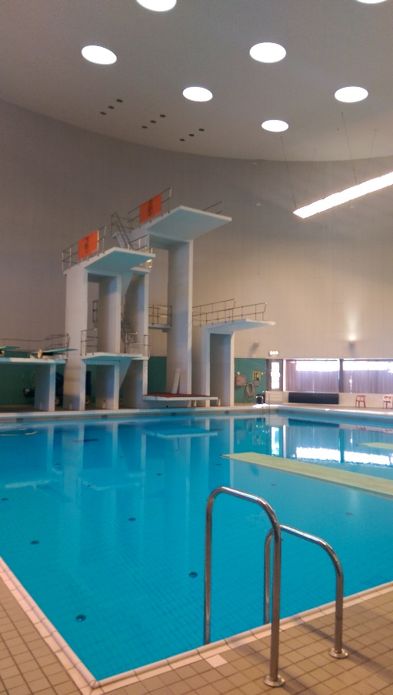
October 26 to 28 2018
WELCOME TO Marginalen Bank Diving Cup
Date: 26 – 28 October 2018
Venue: Eriksdalsbadet, Stockholm
Entry: Use the attached entry form, send it to
e-mail: info@polisensimhopp.se
Entry must be send no later than:
October 3:th 2018
Entry fee: 150 skr/ individual entry, 150 skr/ syncro team.
FEE will be billed
Late entries: Will only be accepted if there is open slots in the
startlists. Fee for a late entry will cost 250 skr. Late entries will be considered until Friday 19:th October.

Admission: Free admission
Awards: Victory ceremony will be held at the end of each event.
Medals and special prices will be presented to the first, second and third of each individual event and synchronized-events.

Dive sheets: We will use www.diverecorder.co.uk during the competition. Instructions for how to entry your dive sheets online, will be presented in a memo after the registration deadline.
However, we kindly ask all competitors to register
sheets online at www.diverecorder.co.uk no later than Monday 22 October. Changes in the dive sheets will be possible until 18.00 the day before the competition. Those who do not voluntarily submit lists in time will be removed from the competition.

Information: info@polisensimhopp.se

Attachments: Events and conditions (Att. 1)
Invitation Masters competitions (Att. 2)
Meals and Accommodation (Att. 3)
Entry Form (Att. 4)
(Available in Word.doc format at:
http://www.polisensimhopp.se/start/?ID=31530

Events and Conditions Att. 1

3m syncro FINA rules for juniors (2+3dives)

1m + 3m Swedish D-group
100 + 200 + 4 free dives from 3 different groups

1m + 3m C Event 1m + 3m FINA:s C list (5+3 boys and 5+2 girls)

Platform C Event FINA:s C list 5-7,5 m (4+3 boys and 4+2 girls)

1+3m B Event FINA:s B list (5+4 boys and 5+3 girls)

Platform B Event FINA:s B list 5-7,5-10m ( 4+4 boys and 4+3 girls)

3m Open Event
Ladies: 5 dives without limit of degree of difficulty, each selected from a different group. Each dive at least 1 ½ somersault.
Men: 6 dives without limit of degree of difficulty, each selected from 5 different groups. Each dive at least 1 ½ somersault.

Platform 5, 7.5 and 10m
5 dives (Ladies) and 6 dives (Men) without limit of degree of difficulty, each selected from a different group.

In the Open Event there will be a final MIX event on Saturday evening. The 4 best men and women will go on and team up for the final. 1st man and 4th women, 2nd man and 3rd women, 3rd man and 2nd woman and 4th man and 1st woman will team up. Each 4 teams will be performing a list comprising of 11 dives, one of these dives will be a synchronised dive. The list will comprise of 5 dives each selected from a different group, the total degree of difficulty of which shall not exceed 9.5, and 6 dives without limit of degree of difficulty, each selected from 5 different groups.
Masters Att. 2
Info: There are NO age group classifications. This means that the diver should participate in the event that is of his or her level of standards. It is not allowed to compete in more categories than one, except for D-group divers who can compete in the C-group Platform event. (Polisens IF wish to inform you that it´s more common to “step up” an age group that the other way around. We recommend clubs/teams that enter divers in the D-group Events, that the divers are no older than 13 years of age, i.e. C-group divers at the oldest.)

.

Invitation Masters Competitions Att. 2

The Masters competition will be an ”all around competition”, on Friday evening October 26, at Eriksdalsbadet in Stockholm.

Competitions: Masters Men and Women from 18 years old (two events) 2+2+2 dives 1m+3m+platform
Freely choose 6 different dives from the FINA handbook excluding dives no 100 and 200.

Masters Novice Men and Women from 18 years old (two events) 2+2+2 dives 1m+3m+platform (only 5m for novice). Maximum 1.5 rotations. Maximum 1.7 difficulty per dive. 100 and 200 are allowed to be used. Dives may be repeated on a different height once. I.e if dive 101c is performed on 1m it is allowed to repeat it on either 3m or platform.

The first two dives will be at 1m springboard for everyone, thereafter you can freely choose the order of your dives for 3m and platform.

Entry fee: 150 SEK per person to be paid at the arena.

Entry: By e-mail to info@polisensimhopp.se where you state your name, masters or novice and men or women. No later than October 3 2018.

Dive sheets: We will use www.diverecorder.co.uk during the competition. Instructions for how to entry your dive sheets online, will be presented in a memo after the registration deadline.
All dive sheets should be registered online at www.diverecorder.co.uk no later than October 22. Changes in the dive sheets will be possible at the arena until 18.00 the day before the competition. Those who do not voluntarily submit lists in time will be removed from the competition.

Awards: There will be medals to the first three in each event

If you have any questions, please don’t hesitate to send an email to info@polisensimhopp.se

Accommodation and Meals Att. 3

Each team will have to make their accommodation bookings. Here are some suggestions:
Clarion (2 minutes walk to the pool), www.clarionstockholm.com
groupreservation.stockholm@choice.se

Quality Globe Hotel (20 minutes walk to the pool), www.globehotel.se
info.q.globe@choice.se

Skanstulls Vandrarhem (Skanstull Hostel) (5 minutes walk to the pool),
Ringvägen 135
www.skanstullsvandrarhem.se.

Mosebacke Hostel
Högbergsgatan 26
E-mail: info@mosebackehostel.se, bokning@mosebackehostel.se
www.mosebackehostel.se

Renstierna Hotel & Hostel
Renstiernas gata 15
E-mail: reservation@hotelrenstierna.se
www.hotelrenstierna.se

Zinkensdamms Vandrarhem (Hostel)
Zinkens väg 20
www.vandrarhemmetzinkensdamm.com.

Meals

Each team can book meals in the pool cafeteria Friday-Sunday.

Lunches Friday, Saturday, Sunday at a cost of 95 skr/person and meal

Dinner Friday and Saturday at a cost of 110 skr/person and meal

Changes in the meal booking can be done until Monday 22 2018, thereafter your booking will be billed.

Entry Form Marginalen Bank Diving Cup 2018 Att.4

Girls/Ladies
Name | Year of birth | D  1m | D  3m | C  1m | C  3m | C  Plat- form | B  1m | B  3m | B Plat-form | Int  3 m | Int Plat-form | Masters

Boys/Men
Name | Year of birth | D  1m | D  3m | C  1m | C  3m | C  Plat- form | B  1m | B  3m | B Plat-form | Int  3 m | Int Plat-form | Masters

Syncronized diving girls:
Te | Dive

Syncronized diving boys:
Tm | Dive

Meals
Please enter how many meals your team wish to book each day

 | Friday 26/10 | Saturday 27/10 | Sunday 29/10
Lunches

Dinners

Team name:____________________________________________________

Coaches names: ________________________________________________

Judges names: ________________________________________________

Billing address:________________________________________________

Send to: info@polisensimhopp.se No later than October 3 2018

Welcome to

